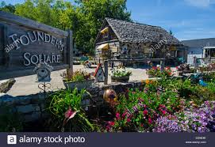  Founders Square in the town of Fish Creek.  What is there to see in Door County?  Enjoy the relaxing atmosphere of small lake towns.  - Visit Fish Creek, Sturgeon Bay, Ephraim and other towns.  - Camp at Peninsula State Park and enjoy the outdoors at Whitefish Dunes State Park.  - Explore the historical and maritime museums in Sturgeon Bay. | About Door County  About Us  Come experience the fresh air and scenic views of the Door County peninsula and the small towns that line the coast of lake Michigan. | Door County Wisconsin  - “Live Life Well”
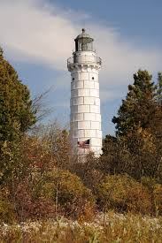  One of several lighthouses on the peninsula  Shopping and Dining and more!  Founders Square  Take a walk around historic founders square in Fish Creek. Browse the various shops and markets where you are sure to find something for everyone! | Camping  Peninsula State Park and Whitefish Dunes State park are both located in Door County, and offer a myriad of trails and campgrounds. Enjoy the sunny beaches and sandy lake Michigan shoreline.  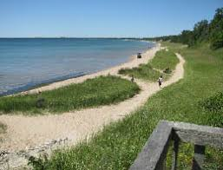 | 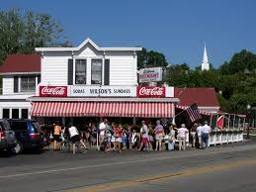  Wilson’s Restaurant featured on the Travel Channel  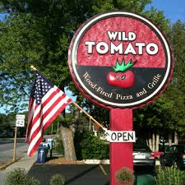  Food!  Visit and enjoy the acclaimed Wilson’s Restaurant in Ephraim or check out Julies Breakfast Café in Fish Creek to start your day, and Wild Tomato Pizzeria and grill later on!

